Day Four – Homework

1. Write a program that declares and assigns a number to a variable (allow decimal numbers) then displays the number and the square to the console in a presentable way.
2. Create a program that assigns values to two integers, one for the amount a test is out of and another indicating what a student received. Display what percentage the student received on the test.
3. Write a program that prompts the user for a six digit number and calculates the product of the 2nd and 5th digit.
4. Create a program that can be used to calculate the final velocity of a car given the initial velocity, the acceleration of the car and the time that has elapsed using the following equation:
$$v_{f}= v_{i}+at$$

5. Given the following declarations:

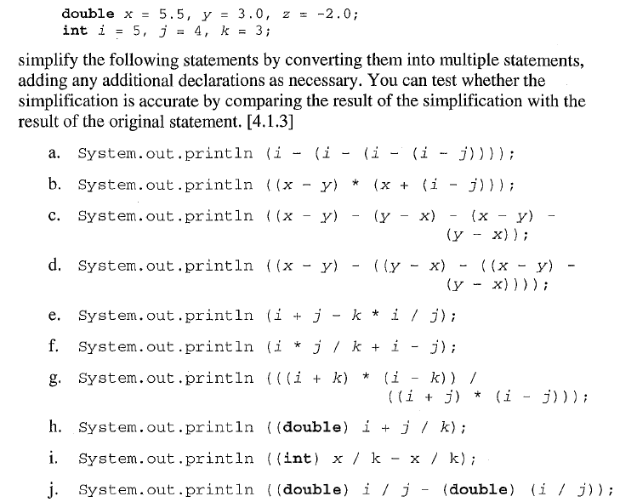

1. Write the output of the following program without actually running the program. You should create a table with the names of the variables as the heading to track what is stored in the variables as you trace the program.

